SPIDAmin Search

SPIDAmin Search is a tool that will create .json files for selecting multiple poles in SPIDAmin. It requires points with object data and a polygon (closed polyline) around just the poles you want in the search files. An easy way to do this is isolate the proposed cable and pole layers. Below is an example polygon and points.

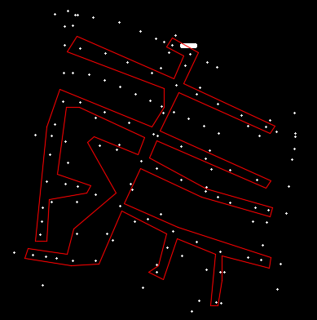

Once this is complete, click on SPIDAmin on the “X” tab. When the program opens, it looks for an Object Data table name that contains “OH” and “STRUCTURE”. If found, it looks for a field named “FID_NUMBER”. If that is found it will auto select it. If anything is not found, you will need to locate the FID field manually and select it.

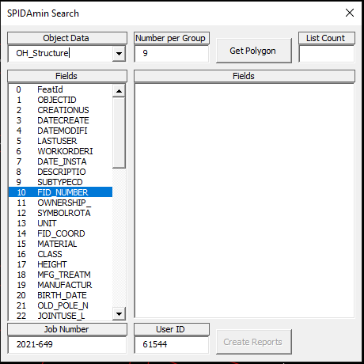

Number of Group has been found to be 9 due to text length limits. For now, User ID is 61544. Job Number should autofill be add or change it if incorrect. Click Get Polygon to get a list of the poles.

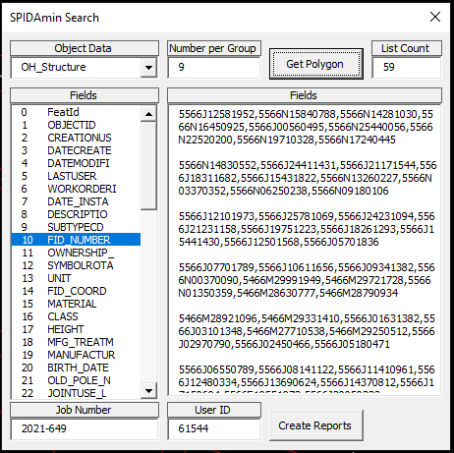

Click Create Reports to create the .json files. They will be placed in the same folder that the drawing is located. This example found 59 poles. At 9 poles max per report, we should end up with 7 reports.

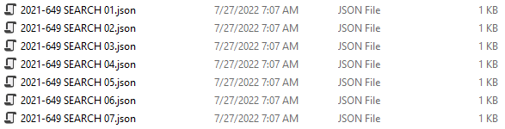

Someone else will probably need to add directions to uses these files within SPIDAmin.